 |  |  | 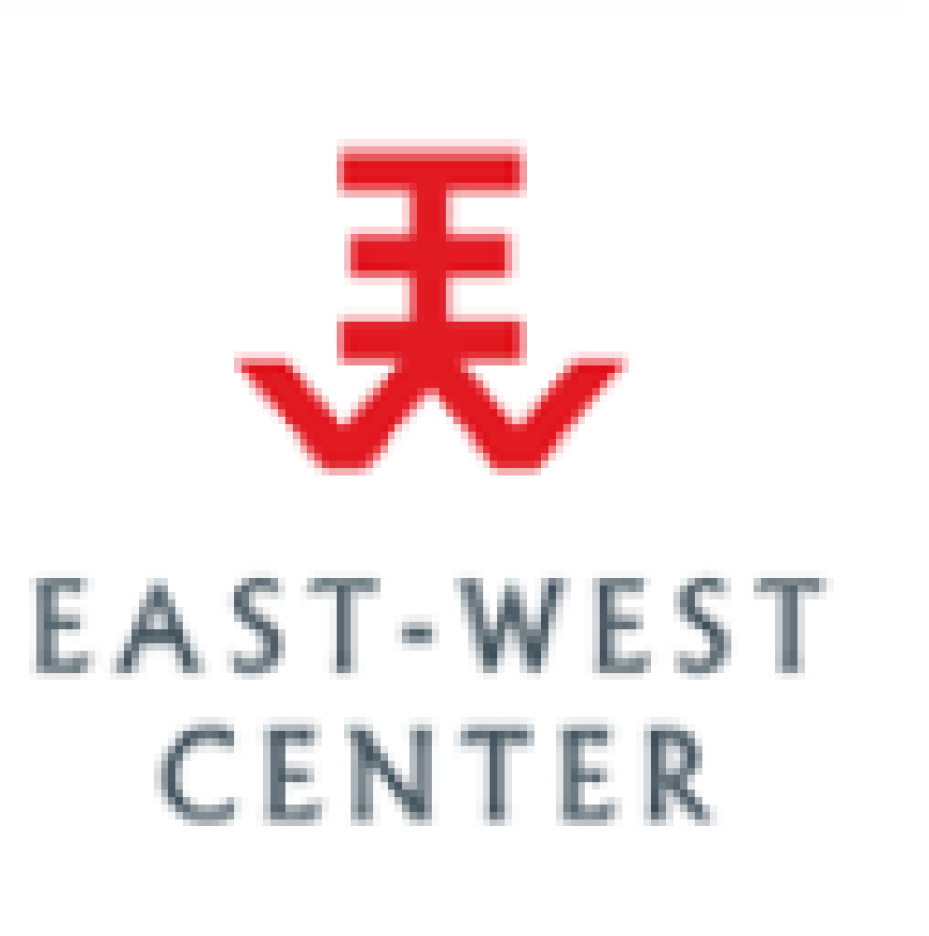 |  | 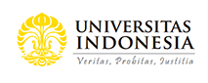 | Universitas Gadjah Mada

Asia-Pacific Regional Virtual Meeting
Using the National Transfer Accounts (NTA)
for Intergenerational Policy Advancement
For NTA Practitioners, Academicians, Government Officials
5-6 October, 2021, 1000-1400 Jakarta Time
Background
Following three regional workshops on the National Transfer Account (NTA) in Asia hosted by UNFPA Asia and Pacific Regional Office together with HelpAge International and the East-West Center held in 2014 (Bangkok), 2015 (Pattaya), and 2017 (Chiang Mai), this virtual meeting is sponsored and co-hosted by UNFPA Asia and Pacific Regional Office together with the Asian Population Association, the East-West Center, HelpAge International, Universitas Indonesia, and Universitas Gadjah Mada. Over a decade, academics, national officials, experts, and policy planners in Asia have become acquainted with the NTA methodology. While several countries have produced NTA and used the results to support policy development, some countries have limited experience in applying the NTA measures and results for policy development. This virtual meeting offers an opportunity to update state of the art knowledge of NTA implications for policy development.
Objectives of the Meeting
1. To generate discussion in using NTA evidence for developing policies addressing the challenges and opportunities posed by demographic diversity and dividends in Asia and the Pacific Region
2. To discuss the policies which could be supported by NTA i.e. ageing policies, health and education policies, women empowerment policies, policies related to fiscal sustainability, welfare support, or policies to address the impacts on COVID-19 etc.
3. To facilitate ongoing cross-country networking and sharing on using NTA for policy issues related to population challenges and opportunities
Participants
NTA practitioners, academicians, and government officials from Asia and the Pacific Region.

Background Documents
- Ronald Lee and Andrew Mason, 2011. Population Ageing and Generational Economy: A Global Perspective. Edward Elgar, IDRC, 2011
https://ageingasia.org/population-aging-and-generational-economy/

- United Nations, Population Divisions, Department of Economic and Social Affairs, 2013. National Transfer Accounts Manual: Measuring and Analyzing the Generational Economy.
https://ntaccounts.org/doc/repository/NTA%20manual%202013.pdf

- A list of publications on NTA topics can be accessed from below
https://www.ntaccounts.org/web/nta/show/Publications

AGENDA
Day1: Tuesday 5 October, 2021
1000-1010  (10 min) | Opening Remarks on behalf of host agencies  Bjorn Andersson, Director of UNFPA Asia-Pacific Regional Office  Aris Ananta, President of the Asian Population Association
1010-1045  (35 min) | Session 1: Introduction of NTA Evidence for Population Policy Development in Asia and Pacific  Chair: Turro Wongkaren, Universitas Indonesia  Speaker: Sang-Hyop Lee, the East-West Center and University of Hawaii
1045-1200  (1hr 15 min) | Session 2: Opportunities and Challenges on Utilizing NTA Evidence for Policy Development  Chair: Michael Hermann, Population Development Branch, UNFPA  - Using NTA on assessment of the COVID Impacts  Miguel Sanchez-Romero, Vienna Institute of Demography  - Investment in gender equality and women's economic empowerment  Gretchen Donehower, University of California at Berkeley  - NTA and Fiscal Sustainability  Sang-Hyop Lee, EWC & UHM  - The NTA handbook on population ageing and sustainable development  Tim Miller, UN DESA
1200-1245  (30 min) | Lunch Break
1245-1400  (1 hr 15 min) | Session 3: Country Studies: What NTA Analysis Reveals - Latest Studies in Asia  Chair: Aris Ananta, the Asian Population Association  - Bangladesh: Joint presentation by Bazlul Haque Khondker, University of Dhaka and Mahboob E Alam, UNFPA Bangladesh  - Iran: Joint Presentation by Majid Koushesi, University of Tehran and Kambiz Kabiri, UNFPA Iran  - Maldives: Fathimath Riyaza, Maldives Bureau of Statistics  - Korea: Hyun Kyung Kim, EWC and University of Hawaii, Korea

DAY 2: Wednesday 6 October, 2021
1000-1045  (45 min) | Session 4: Round Table Discussion: Using NTA Evidence for Policy Development  Chair: Rintaro Mori, UNFPA Asia-Pacific Regional Office  - Maliki, Ministry of National Development Planning (BAPPENAS), Indonesia  - Suphannada Lowhachai, the National Economic and Social Development Council, Thailand  - Michael Hermann, Population Development Branch, UNFPA
1045-1200  (1 hr 15 min) | Session 5: Country Studies: What NTA Analysis Reveals - Latest Studies in Asia & Latin America  Chair: Wassana, UNFPA Asia-Pacific Regional Office  - India: M.R. Narayana, Fiscal Policy Institute, Government of Karnataka  - Malaysia: Dato' Dr. Tengku Aizan Tengku Abd Hamid, Universiti Putra Malaysia  - Sri Lanka: Lakshman Dissanayake, University of Colombo  - Latin America: Cassio Turra, Cedeplar-Federal University of Minas Gerais
1200-1230  (30 min) | Lunch Break
1230-1345  (1 hr 15 min) | Session 6: Round Table Discussion: Improving NTA as a policy tool: Where NTA has been effective, where not, and what is missing.  Chair: Eduardo Klein, HelpAge International  Panelists:  - Andrew Mason, The East-West Center and University of Hawaii  - Tim Miller, Population Division, UN DESA  - Sang-Hyop Lee, The East-West Center and University of Hawaii  - Gretchen Donehower, University of California at Berkeley
1345-1400  (15 min) | Summary and Conclusion: Development of NTA - Achievements and Future Prospects for Asia –  Sang-Hyop Lee, The East-West Center and University of Hawaii  Turro Wongkaren, Universitas Indonesia
Master of Ceremony: Evita Hanie Pangaribowo, Universitas Gadjah Mada

